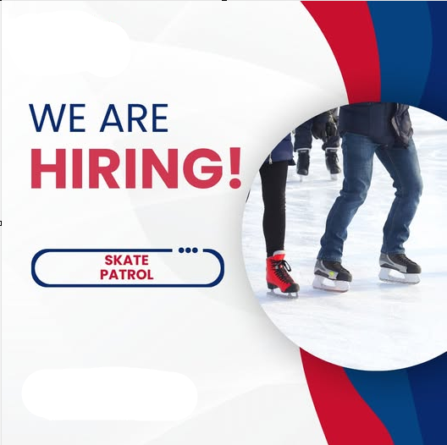
Inquire at:
www.gatewayrec.com
gm@gatewayrec.com
204-982-1234 ext 1
PUBLIC SKATING

GATEWAY RECREATION CENTRE

